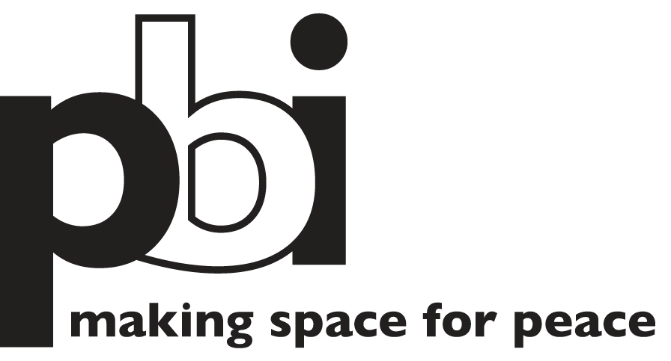

Job description – Full Time Interpreter

Organisation: Peace Brigades International-Nepal Project

Location: Nepal

Reporting to: In Country Coordinator

Language:
- Excellent English, fluency in oral and written Nepali is essential. Knowledge of Tharu and other local languages is highly recommended.

Experience:
- Professional interpretation in INGO work environment or similar;
- Work experience in human rights or related fields is an asset, as is familiarity with current human rights issues in Nepal.

Main activities and duties:
- Provide general interpretation and translation for international volunteers/staff of PBI-Nepal Project;
- Responsible for providing high-quality spoken interpretation and written translation work covering a range of subjects including political, social, legal, human rights and security related terminology;
- Interpret at various meetings as and when the need arises - this includes interpreting for the field volunteers during meetings with government officials, NGO’s, interviews with victims and organizations. Act as interpreter during field missions to assist the field volunteers in gathering information related to human rights and to human rights violations in the current context;
- Assist in translating confidential or other documents from Nepali to English and English to Nepali, ensuring that all deadlines are met and the quality of translation is adequate;
- Media monitoring and analysis of Nepali language media
- Some language learning assistance to PBI volunteers
- Perform other related logistical and administrative functions, as required.

Skills:
- Ability to work in an international and multi-ethnic environment
- Good interpersonal skills
- High awareness of the sensitivity of the work to be undertaken
- Discretion and confidentiality essential
- Knowledge of the historical, political and cultural situation of Nepal
- Good physical condition
- Driving license an advantage, not essential
- Willingness to travel and work evenings or weekends when needed

