PEACE BRIGADES
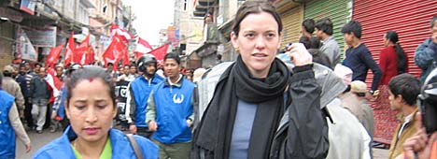
INTERNATIONAL

Protecting Human Rights
Promoting nonviolent transformation of conflict
Peace Brigades International (PBI) sends international volunteers to areas of conflict, providing protective accompaniment to human rights defenders threatened by political violence. Founded in 1981, sponsoring groups in Europe, North America, Australia/NZ now support teams in Guatemala, Mexico, Colombia, Indonesia, and Nepal. Previous teams have served in Haiti, El Salvador, the Balkans, Sri Lanka, Canada, and the USA.
Learn about their work, and the project in Nepal
Speakers:
Katherine Hughes-Fraitekh, Executive Director, PBI / USA
Krystal Mason, Team member currently in NEPAL

Monday, January 26, 7:15
Kendal Auditorium

Sponsored by Kendal Voices for Peace & Justice & Kendal Friends Meeting

