Inés and Valentina:
Breaking the wall of impunity.
informative report

I. Presentation

On 1st October, the Inter-American Court of Human Rights (IAHR Court) announced two sentences against the Mexican State in the cases of Inés Fernández Ortega and Valentina Rosendo Cantú. The verdicts represent an acknowledgment of the search for justice that both women from the indigenous Me’phaa people had maintained for over eight years, after being raped and tortured by soldiers from the Mexican Army in 2002.

The sentences relate to key issues in the current human rights situation in Mexico, referring to problems such as the lack of access to justice for female victims of violence; abuses caused by the increasing lack of civilian control over the Armed Forces and the obstacles faced by those who organise in order to defend the rights of indigenous peoples.

II. Who are Valentina and Inés?

Valentina Rosendo Cantú and Inés Fernández Ortega are indigenous Me’phaa (Tlapaneco) women, from communities located in Ayutla municipality, in the Montaña region of Guerrero; characterised by poverty and exclusion. Both women, at different times in 2002, were raped and sexually tortured by soldiers from the Mexican Army, who were deployed on military operations in the region that, according to the justification provided at the time and maintained to date, aimed to combat the cultivation of drugs and contain groups that are considered subversive.
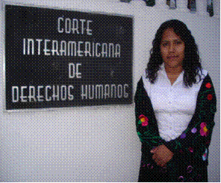
On 16th February 2002, Valentina was just seventeen and her daughter barely three months old. Valentina was doing the washing in a stream near to Barranca Bejuco, the community where she lived, when she approached by eight soldiers from the 41st infantry Battalion, who questioned her regarding the whereabouts of “hooded” men (belonging to the guerrilla). When Valentina answered that she did not know any, they pointed their weapons at her and threatened her. Then, they showed her a photograph and asked who the person was. Furthermore, they showed her a list of eleven names, which included members of the organisation that would come to be known as the Indigenous Me’phaa People’s Organisation (Organización del Pueblo Indígena Me’phaa, OPIM). One soldier hit Valentina in the stomach with the butt of his rifle, causing her to fall to the floor. Another pulled her hair whilst he continued to interrogate her. Finally, in front of the rest of the soldiers, two of them raped and tortured her.

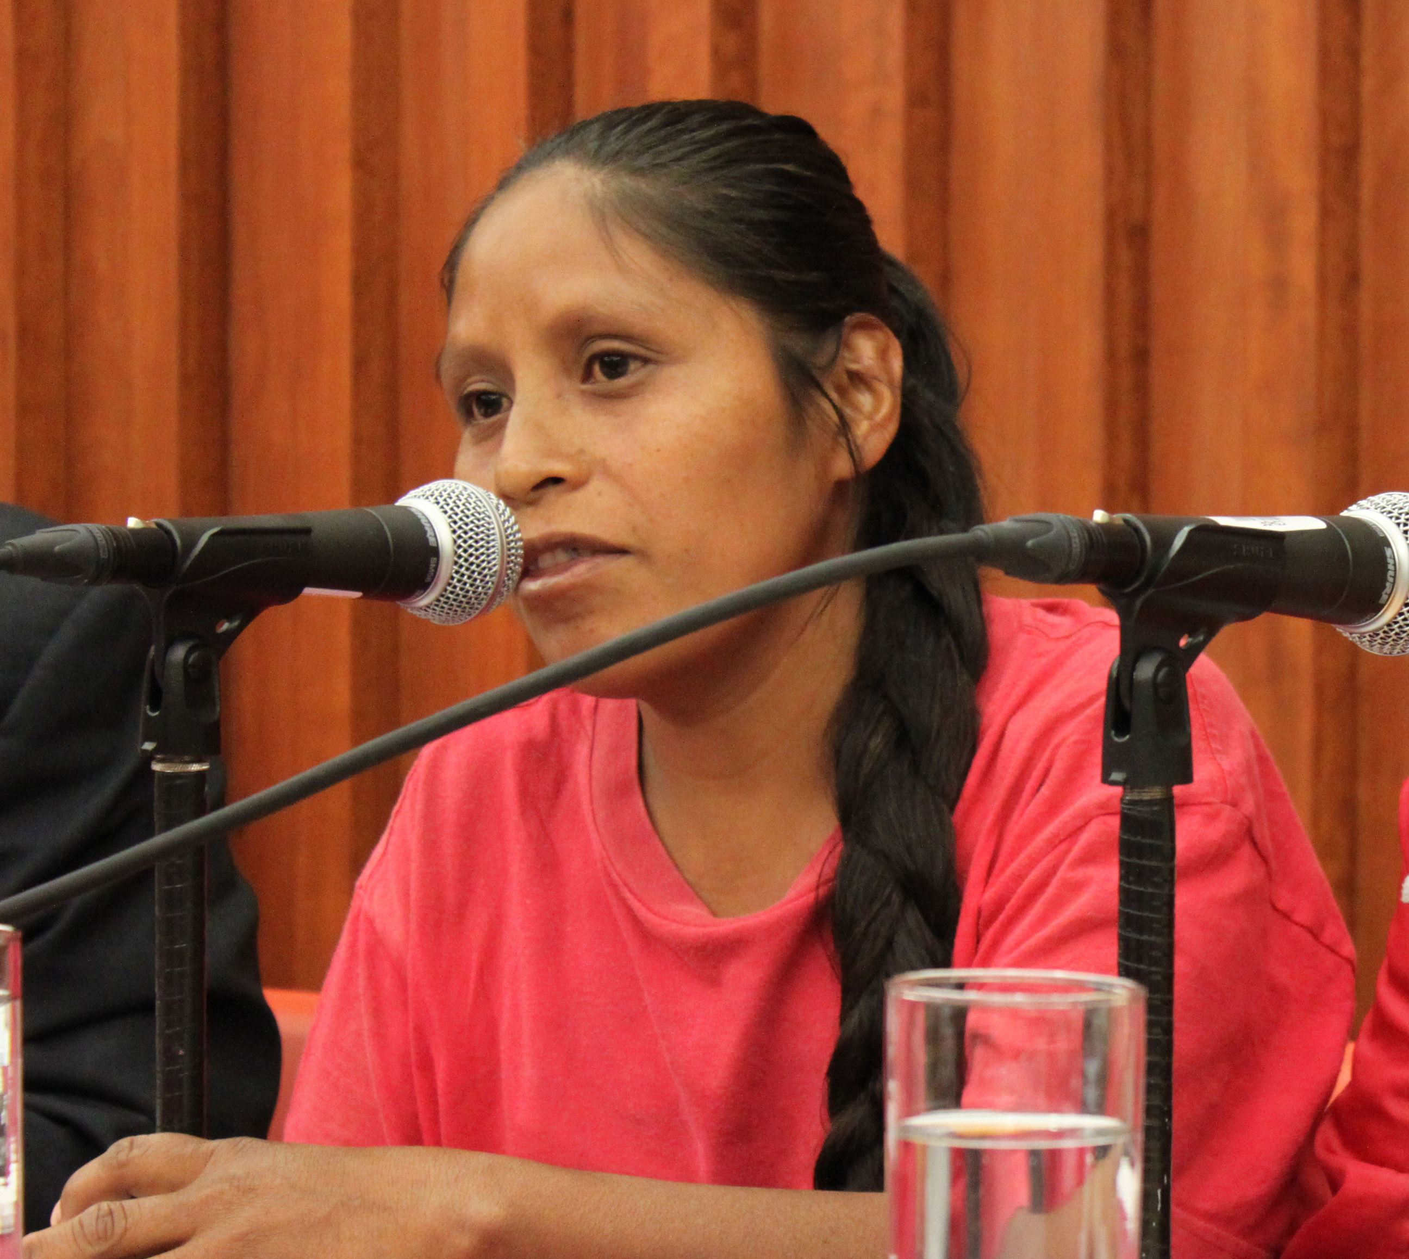
Twenty-nine days later, on 22nd March 2002, Inés Fernández Ortega, 25 years of age, was also attacked whilst she was in her kitchen, with her four children playing in the room next door. Eleven soldiers from the 41st Infantry Battalion arrived at her house in Barranca Tecoani. Three of these soldiers entered the kitchen without her consent and interrogated her about her husband, a member of the OPIM, whilst pointing their weapons at her. Inés was unable to respond, out of fear and because she couldn’t speak Spanish. One of the soldiers began to interrogate her again, shouting at her to answer, while two soldiers pointed their weapons at her. One of the soldiers grabbed her by both hands and told her to get down on the floor, whilst he continued to interrogate her. Inés obeyed and got down on the floor. Straight away he got on top of her and raped her.

After being attacked, both Inés and Valentina began a difficult journey, characterised by negligence, lack of transparency and discrimination. With regards to the justice system, the investigations were partial and not at all swift; for example, in Inés’s case, the Public Prosecutor’s Office even managed to lose fundamental evidence. In addition to this, in both cases the civilian authorities allowed the unfinished investigations to be sent to military jurisdiction where the lack of independence and impartiality that characterises these authorities meant that impunity prevailed, even though both women unsuccessfully contested the decision by registering injunction appeals. With regards to access to comprehensive health services, both women lacked effective medical attention from the state authorities, despite being female victims of violence and this resulted in further complaints. At all times, Inés and Valentina’s identity as indigenous women was either ignored, or only taken into account in order to discriminate against them.

III. What has the search for justice meant for Inés and Valentina?

Daring to denounce what happened has had significant implications on Inés and Valentina’s lives. Both Me’phaa women have faced stigmatisation as a result of making the events public, as well as the risks implied in speaking out against the Army. Throughout the process the threats against them have been constant and have extended to their families as well. In the case of Inés, who belongs to the OPIM, the threats have even extended to other members of the organisation.

The severity of the risks has been corroborated by the IAHR Court, which in 2009, ordered the Mexican State to adopt urgent provisional measures to avoid either of the women or their families from losing their lives of their personal integrity.

Today, Inés and Valentina are still recovering after this traumatic experience that transformed their lives and whose effects continue until the present day. As victims of serious human rights violations, their persistence in the search for justice has made them into promoters of the right of all women to live a life free from violence. Consequently, full compliance with the reparations ordered by the Court and guaranteed security are essential in order them for continue reconstructing their lives.

IV. What did the Inter-American Court decide?

After all of the national recourses were exhausted, without those responsible being punished, Inés and Valentina’s cases were presented before the Inter-American Commission in 2003. Once this authority decided that the allegations had been proven, it decided to submit the cases to the Inter-American Court of Human Rights’ jurisdiction in 2009; the Court heard the victims’ voices and the arguments of both sides during public hearings held in April and May 2010.

Finally, the Court announced its sentences on 30th and 31st August. It was considered that the allegations had been fully proven: Inés and Valentina were raped by soldiers from the Mexican Army in a context characterised by poverty, discrimination and what it referred to as “institutional military violence.” In order to analyse what had happened, it applied and interpreted three international treaties and concluded that the rape of both Me’phaa women had been an act of torture. Consequently, it ruled that the following rights had been violated: to a life free from violence; not to be tortured; the victims’ families’ right to personal integrity; to the protection of dignity and a private life and to due process and legal guarantees. Moreover, it ruled that Mexico had failed to comply with its obligation to adjust the national legal framework to the parameters derived from international treaties.

Accordingly, the highest inter-American court ordered reparations including:

- A public act to acknowledge the State’s responsibility, which would mean putting an end to the questioning of Inés and Valentina’s accusation, which has lasted for over eight years.
- The investigation, trial and punishment of the soldiers responsible for the rapes, carried out by civilian authorities under conditions that do not result in further risks or threats.
- The reform of Mexican law with regards to military jurisdiction (article 57 of the Code of Military Justice).
- The publication and dissemination of the sentence.
- The foundation of a community centre to support indigenous women; managed by the communities in the Ayutla de los Libres region.
- Fair compensation that covers both material and non-material damage.
- The adoption of the necessary measures to ensure that these events do not take place again, including measures such as strengthening the authorities within the justice system that try cases of gender violence in Ayutla de los Libres; the adoption of adequate investigation protocols in order to look into formal complaints made by women in such cases and training for officials, including soldiers, among others.

V. Why are the sentences from the Inter-American Court important and relevant today?

In the current context, compliance with the sentences announced regarding Inés and Valentina’s cases will allow both Me’phaa women to access justice and also make it possible to discuss and make visible certain matters of fundamental importance on the national human rights agenda.

For example, nowadays, as multiple human rights violations are being registered in the context of the so-called war against drugs, the sentence will oblige the State to discuss the necessary adoption of external civilian mechanisms for monitoring the Armed Forced in the investigation and prosecution of cases relating to military abuses, such as the restriction of military jurisdiction. Likewise, the sentence will prompt an evaluation of what has been done by Mexico to guarantee indigenous women who are the victims of violence to access justice: this implies carrying out an in-depth revision of all the institutional patterns that perpetuate discrimination.

Previous experiences demonstrate that, as opposed to the tendency in other Latin American countries, the Mexican State as a whole and the Federal Government in particular, have been reluctant to comply, both promptly and fully, with the sentences from the Inter-American Court, despite the fact that it has expressly accepted the jurisdiction of this court by acknowledging the binding nature of its sentences. Therefore, it is necessary for the implementation process to by monitored in a timely fashion by civil society and public opinion, as well as by other political and social actors committed to strengthening democracy and human rights. Otherwise, the sentences could remain unfulfilled.

Apart from this, it is important to mention that for Inés and Valentina, the greatest priority is to be allowed to live in peace and safety. Since the cases arrived at the IAHR Court and they participated in proceedings whereby they identified the soldiers that raped them, the threats against them, their families and the organisations that have accompanied them, have increased. Following the announcement of the verdict the risk is even greater, not only because an international court has determined the State’s international responsibility, but also because the Court’s resolutions order an investigation in ordinary legal jurisdiction in order to identify those responsible, as well as their trial and punishment, which is a priority for the victims. Therefore, a central demand in both cases is for the State to assume responsibility for allowing both Me’phaa women to rebuild their lives and live in peace with their families.

V. How can we obtain more information on the cases?

In order to obtain more information on the cases of Inés Fernández Ortega and Valentina Rosendo Cantú, regarding the legal process (facts, dates and other details from the case files), audiovisual material, or to request interviews, please contact:

Tlachinollan
Human Rights Centre
Tlapa de Comonfort, Guerrero, Mexico
Telephones: (01 757) 47 6 12 00, 47 6 12 20.
Email: tlachi.internacional@gmail.com
http://www.tlachinollan.org/
http://justiciaporinesyvalentina.wordpress.com/
The sentences are available in Spanish at: http://www.corteidh.or.cr/

